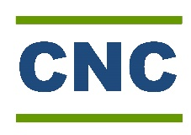
Youth Participation Payment Form
Please use this form if you are aged 12-25, are helping to facilitate a community event, participating in a community meeting/discussion, or offering your time towards the CNC youth program in any sort of official capacity.
Please speak to Adele or another CNC staff member if you are unsure how to fill this out correctly, or if you need clarification regarding your personal involvement.
Name: | BSB Number: | Account Number:

Date: | Duration: | Description: | Total: | Paid?

This form may be used for more than one activity/event if required, however we can only pay you once the form has been returned to the CNC.

39 Hanson st Corryong
02 6076 2176
adele@corryongnc.org

